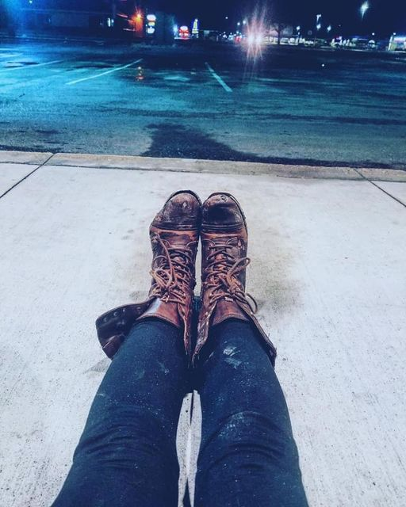

ANNUAL REPORT

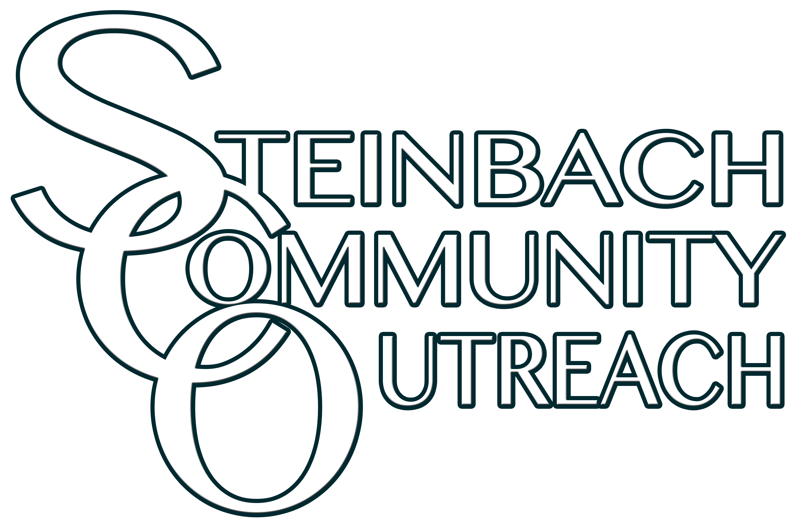
2020
STEINBACH COMMUNITY OUTREACH
Email: steinbachoutreach@gmail.com  Website: www.steinbachcommunityoutreach.com | Tel: 204-326-7954  345 Loewen Blvd. Steinbach MB R5G 0L1
TABLE OF CONTENTS
About Steinbach Community Outreach 2
Mission Statement 3
Board Report 3
Executive Director’s Report 4
Housing Director's Report 5
Program Updates 6
Thank you to our Volunteers 6
FINANCIAL SUMMARY 7
FINANCIAL STATEMENTS 8
Statement of Financial Position 8
Statement of Comprehensive Income (Profits and Losses) 9
Statement of Cash Flows 10
Auditors Report 11
Highlights 12
Organizational Structure 12
Thank you to our Donors 14

steinbach community outreach

Mission statement

Steinbach Community Outreach assists people in Steinbach who are struggling to meet their essential needs. We focus our energies on those living in poverty, experiencing homelessness and those at risk of becoming homeless, by filling the gaps left by other programs and organizations. We do this by addressing their unmet essential needs of food, clothing, shelter and relationship; and assisting them in accessing available services.

Board report
What a year it has been! 2020 was a year of challenges, growth, and transition at Steinbach Community Outreach. Between the SCO-Today House amalgamation, the impact of Covid to operations, and a local community with increased needs; our board, staff, and volunteers had their hands full.
It was in February of 2020 when Simone Penner and the Today House board formally invited us to discuss an SCO-TH amalgamation. While there was initial excitement at the possibilities and efficiencies that could be gained from combining forces, both parties worked hard to ensure that this was the right decision, and that all due diligence was completed. So far the results have been encouraging, the home is rarely (if ever) empty and it has allowed us more flexibility when finding our clients shelter. Thank you to Simone Penner, Kent Ledingham, Dolly Fuchs, and Brittany Penner for being excellent partners throughout this transition and for all your efforts with Today House over the years.
The Covid pandemic has had a massive impact on how the world operates, and SCO was not spared from this challenge. Whether it meant spacing out chairs to properly social distance, having coffee and connection outside, or planning around restrictions/quarantines when finding shelter for clients, the staff and volunteers stepped up in a significant way. I would like to acknowledge Myra Gerbrandt for her work managing the drop-in center, as well as Irene Kroeker and Tammy Bekkering for their work related to housing. Also, thanks to Charlene Kroeker for all your efforts behind the scenes.
For the first time in a few years, we are pleased to welcome 2 new members to the SCO board, Dolly Fuchs, and Brittany Penner. Both Dolly and Brittany were members of the Today House board and we are delighted that they have chosen to join us. Dolly will also be taking on the role of Treasurer as Eric Rempel has chosen to step down. Thank you Eric, for your many years of dedicated service.
Finally, I want to express my genuine thanks to our donors, who give so generously, and allow SCO to provide the desperately needed support to our clients. I also want to thank the volunteers and staff of SCO, your willingness to go above and beyond while taking care of those less fortunate is inspirational!
Thank you,
Elroy Peters, Board Chair

Executive Director’s report
The year 2020 will become one of the most talked about years in our history of the world. We have lived through it and hopefully 2021 will be a year of recovery. SCO’s door remained open throughout this difficult time. Yes, we had to do things differently. We had our challenges, but we faced them, became very creative and survived. It was the worst of times, and the best of times.
The worst of times by far is the lack of connection we had with our guests. Isolation, social distancing, masking, and not having social times took its toll on our guests and our volunteers. However, there was also “the best of times” throughout the year. It brought the staff closer together. We had to be creative, put our heads together and figure out how best to help our guests. The staff was incredibly there for people in many ways. Yes, we had to find alternative ways of finding food, clothing, and toiletries but we also found creative ways of connecting. No, we were not able to meet, but we could “help from afar” or meet one on one. We are also very grateful that we have all remained healthy.
Programming took on another kind of life. Myra and her helpful volunteers dropped off hampers for people. Tammy and I connected with the homeless at a safe distance and were able to place 62 homeless people regardless of the pandemic and its restrictions. We also were able to assist 22 people from becoming homeless. Charlene did a lot of research, found grants, filled out forms and took on the bookkeeping for Today House as well as SCO. Yes, it took “out of the box” thinking, but God was with us and it we got through it. Thank you for our incredible staff and their talents.
Two of our volunteers won awards this year for their service at SCO. John Kroeker won the Sovereign’s Medal for Volunteers for his work with the income tax program and Tammy Bekkering won the Manitoba 150 volunteer service award for her work with our advocacy programming and the transitional house.
Our biggest blessing has been the acquisition of Today House. In the midst of code red, and orange and whatever color, we were given the opportunity of running the emergency shelter.
We also welcome the Aulneau counselling agency back into their space. The number of people accessing SCO’s counselling program tripled in 2020. They have been an essential part of our community and are finally able to counsel in person again.
We look forward to the day we are able to open our doors for coffee, snacks and connection in the future. God has blessed us, and we are eager to follow His direction. All the best in the new year, and all that it will bring us…….
Irene Kroeker
Executive Director

“Volunteering is the ultimate exercise in democracy. You vote in elections once a year, but when you volunteer, you vote every day about the kind of community you want to live in.” ~Author Unknown

Housing Director’s Report
It’s been a busy year for housing the homeless. When Covid hit we knew it would impact those we help and it definitely did. Out of 365 days we had someone in the Today House overnight shelter for 307 days! There also seemed to be an increase in domestic situations and we ended up having several people stay in our transition apartment who were escaping a domestically violent situation. We were also able to offer the transitional apartment to a senior couple who had a fire in their house and needed a place to stay while the damage was being repaired. The transitional apartment was occupied for 10 ½ months out of the year.
During this year we also took over the complete running of the Today House shelter. We changed the format up a bit and found a new couple to live as caretakers of the property. They are clients of ours and are thrilled to be living on the main floor of the house so it was a win-win situation. We are no longer hiring house parents but we have instead set the shelter up with more independent accommodations. So far the transition has been very smooth and the new system has been working well for us. We find we have more requests for both the shelter and the transitional apartment than we can accommodate so we are considering the need to add another transitional living option in the future.

2020 Program Updates
Free Income Tax Clinic: We filed over 125 tax returns for low income households.
Today House: Today House provided 307 nights of emergency overnight shelter to 90 individuals.
Transitional Apartment: The transitional apartment was occupied 10 and ½ months out of the year to multiple families and individuals.
Advocacy: Our advocacy program transitioned 46 individuals and families off the streets and prevented an additional 22 families and individuals from becoming homeless.
Drop In Centre: We handed out an average of 182 food hampers and 65 hygiene hampers per month to over 400 households who are food insecure and marginally housed. Coffee and hangout times were restricted and sometimes suspended due to provincial Covid-19 restrictions.
Counselling: The number of people accessing counselling services through our counselling program tripled in 2020.

Thank you to our volunteers
We could not operate without the time and energy invested by our volunteers who work tirelessly to help our guests in need. In 2020 we had 60 volunteers using their talents to support others. Thank you to everyone for your dedication and commitment to making a difference in the lives of others! Congratulations to John Kroeker who won the Sovereign’s Medal for Volunteers for his work with the income tax program and Tammy Bekkering won the Manitoba 150 volunteer service award for her work with our advocacy programming and the transitional house.
“If our hopes of building a better and safer world are to become more than wishful thinking, we will need the engagement of volunteers more than ever.” — Kofi Annan~Author Unknown

“Volunteering is the ultimate exercise in democracy. You vote in elections once a year, but when you volunteer, you vote every day about the kind of community you want to live in.” ~Author Unknown
~Author Unknown

FINANCIAL SUMMARY

Steinbach Community Outreach continues to operate based entirely on donations and grants. This year we did receive some government grants to cover the operating costs at Today House and to continue our food programing. Since we were unable to do any fundraising due to Covid-19 the government made these grants available so we could continue to support people most in need.
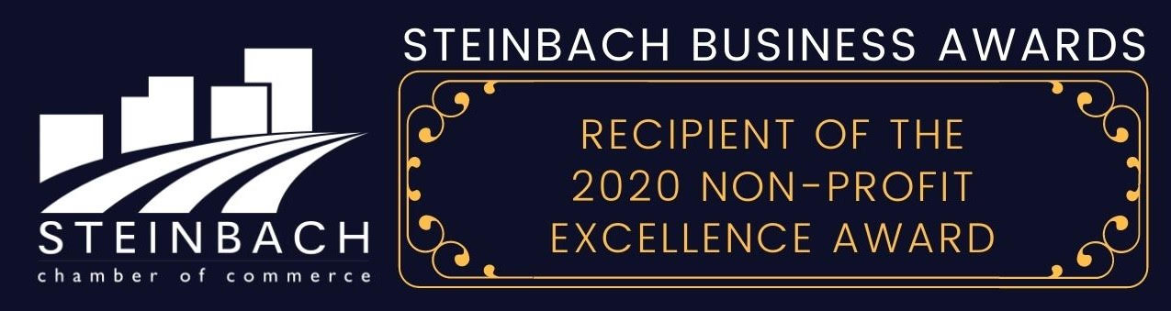

FINANCIAL STATEMENTS

Statement of Comprehensive Income (Profits and Losses)

Statement of Cash Flows

INDEPENDENT AUDITOR’S REPORT

Auditor’s Report

Organizational STRUCTURE

The Board
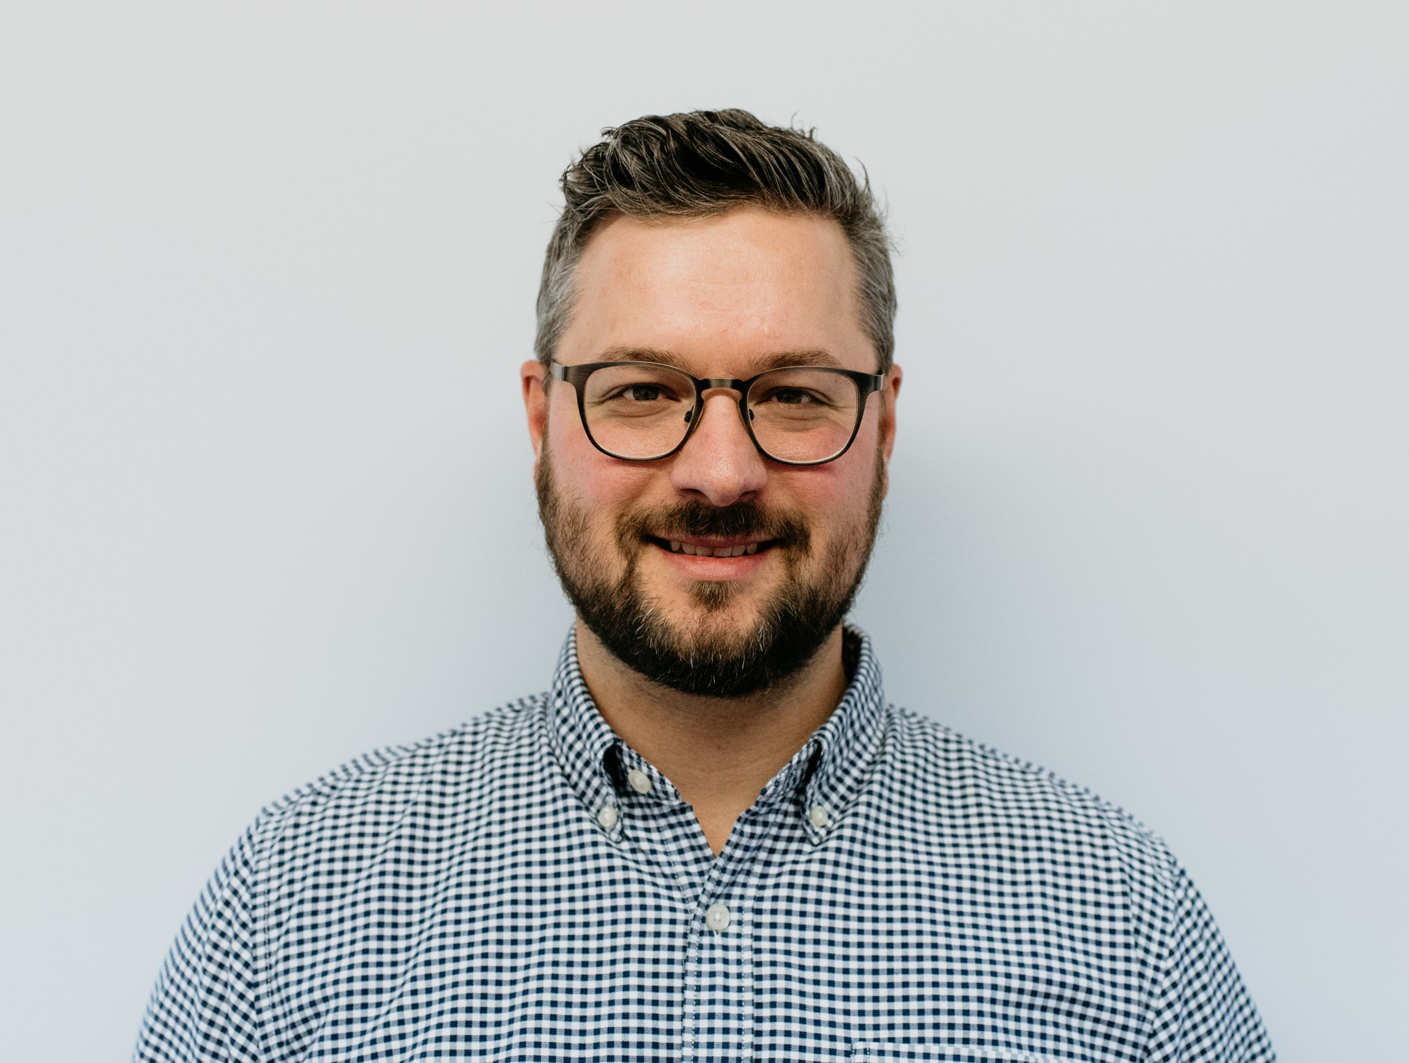
Board Chair
Elroy Peters
HyLife - Operations Manager – Feed Division

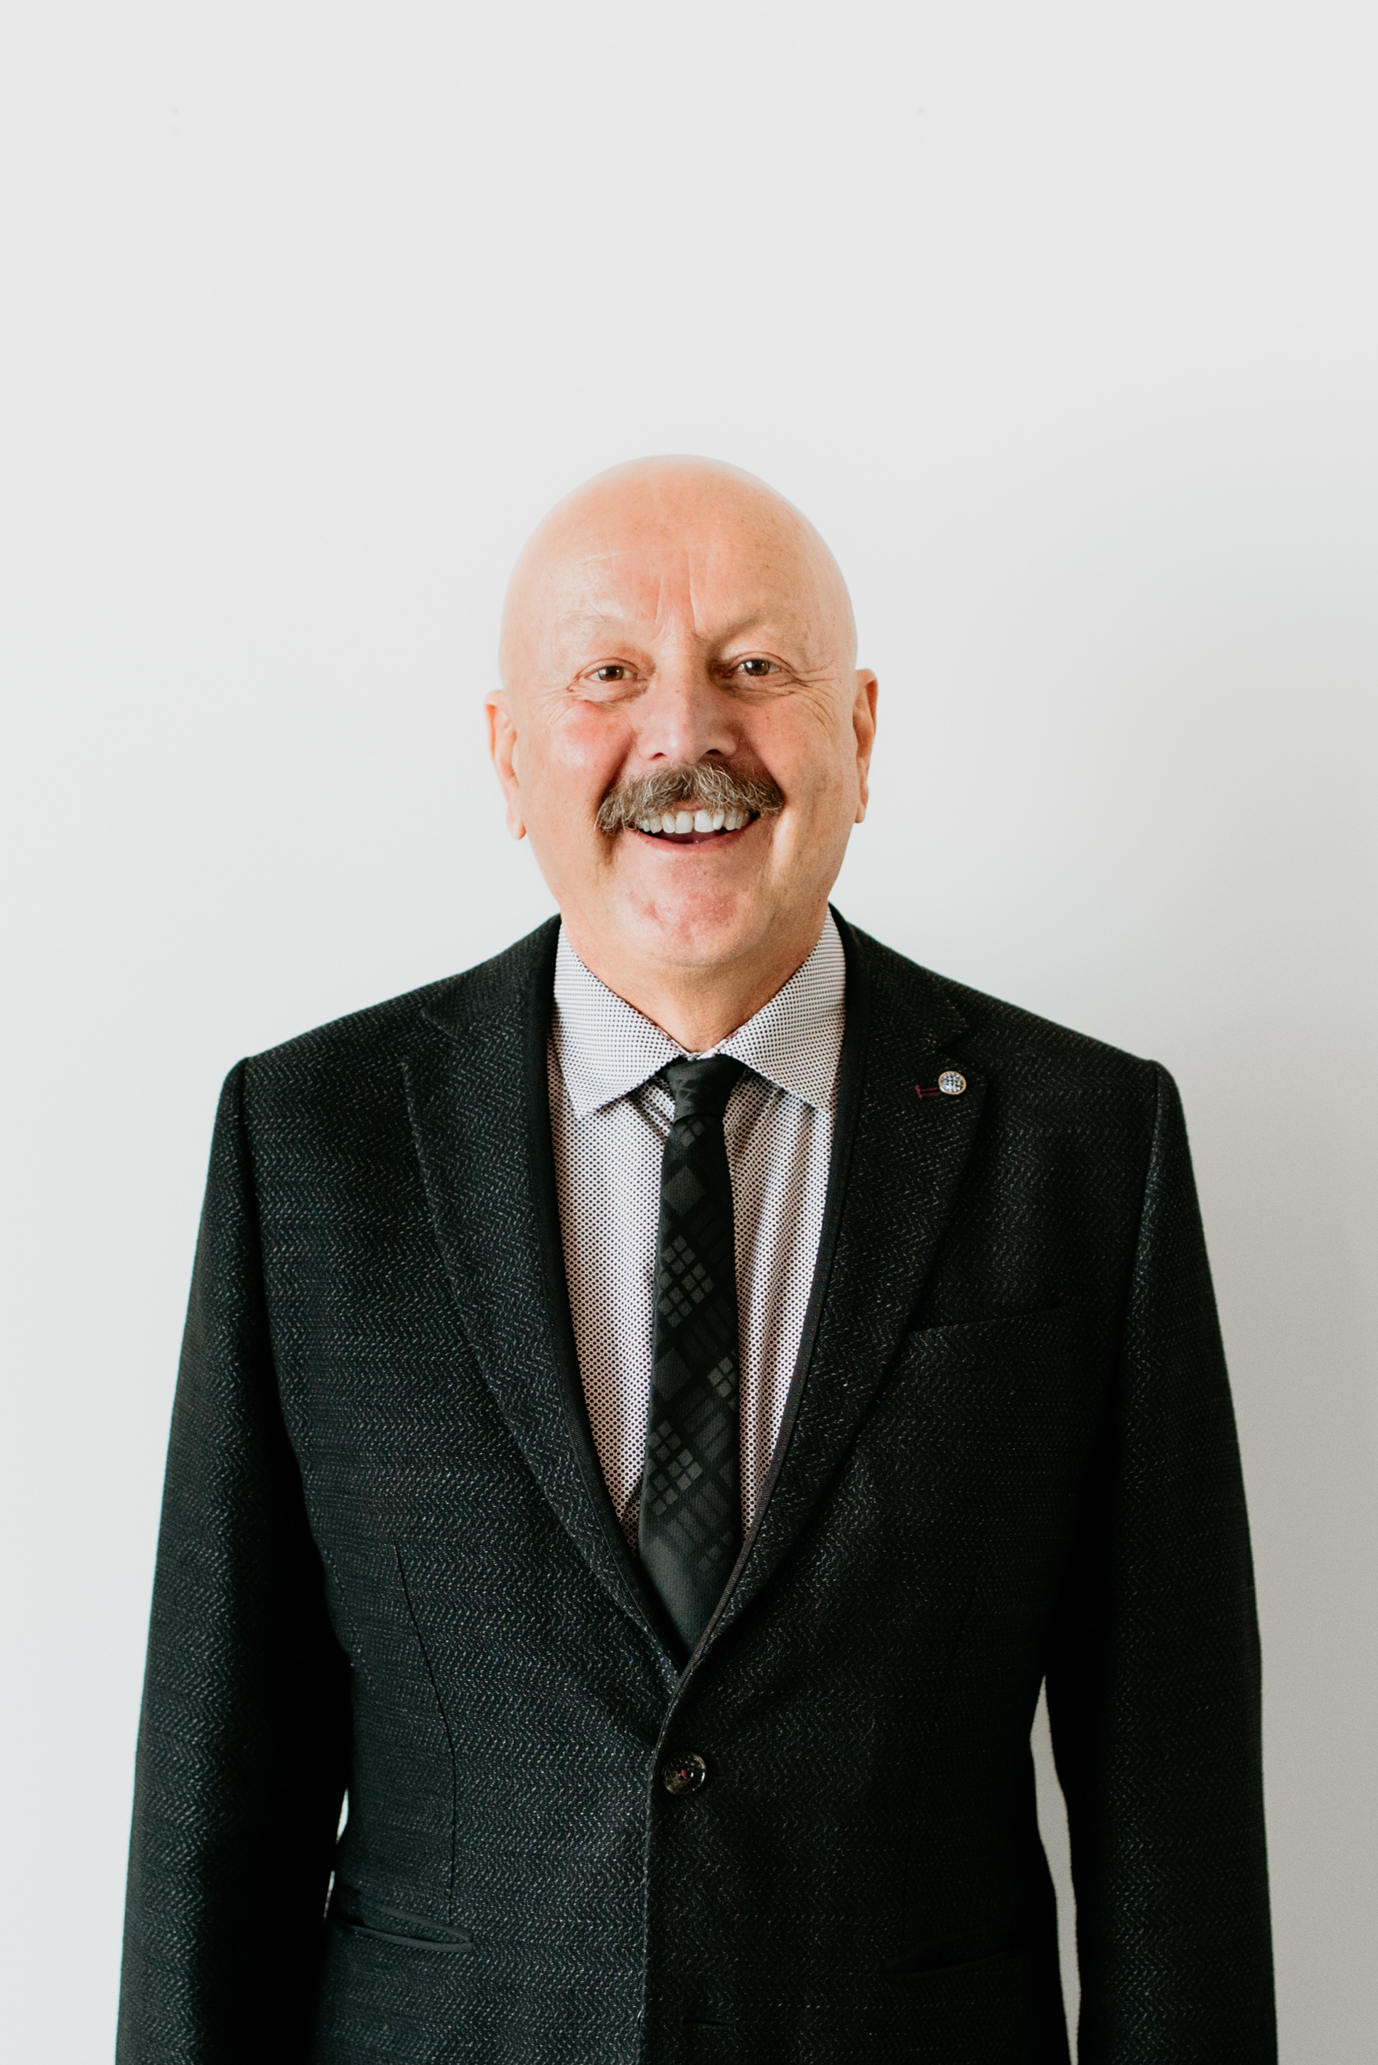
Vice Chair
Bob Schinkel
Schinkel Properties – Owner/Operator

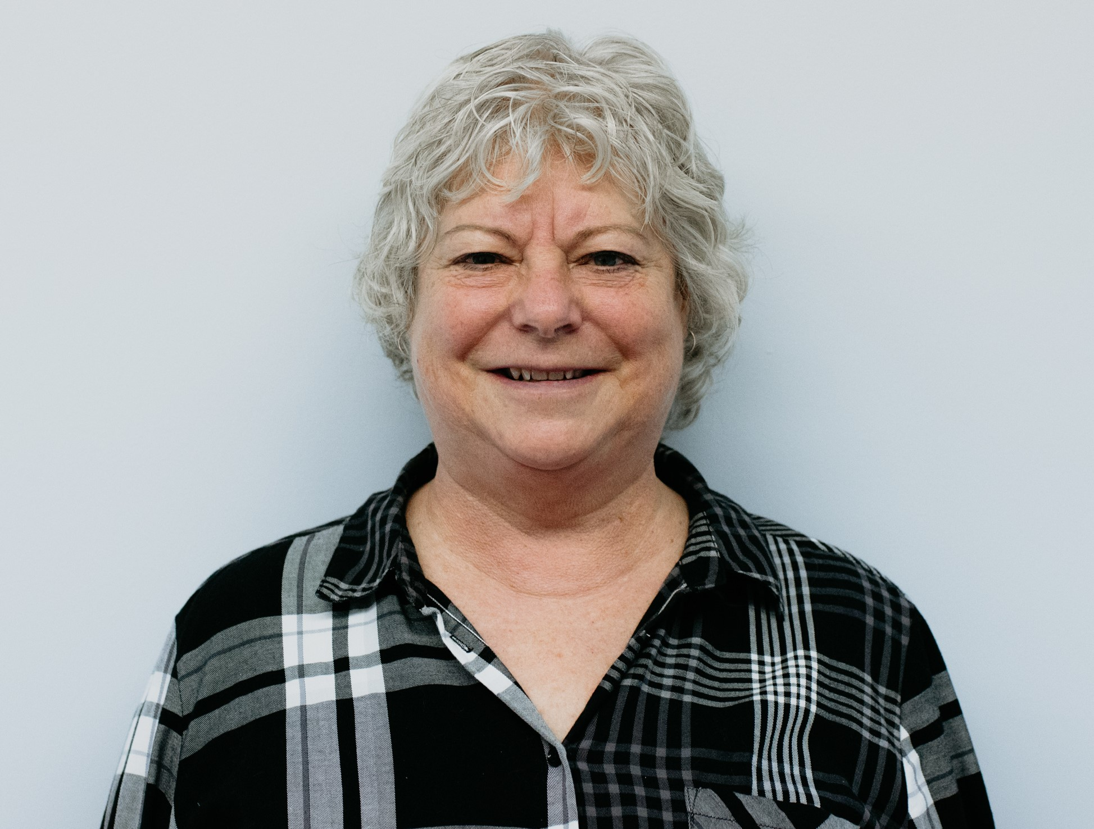
Executive Director; Founder
Irene Kroeker
Retired - Teacher

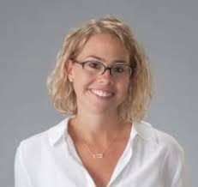
Treasurer
Dolly Fuchs
Director of Operations City of Steinbach Chamber of Commerce

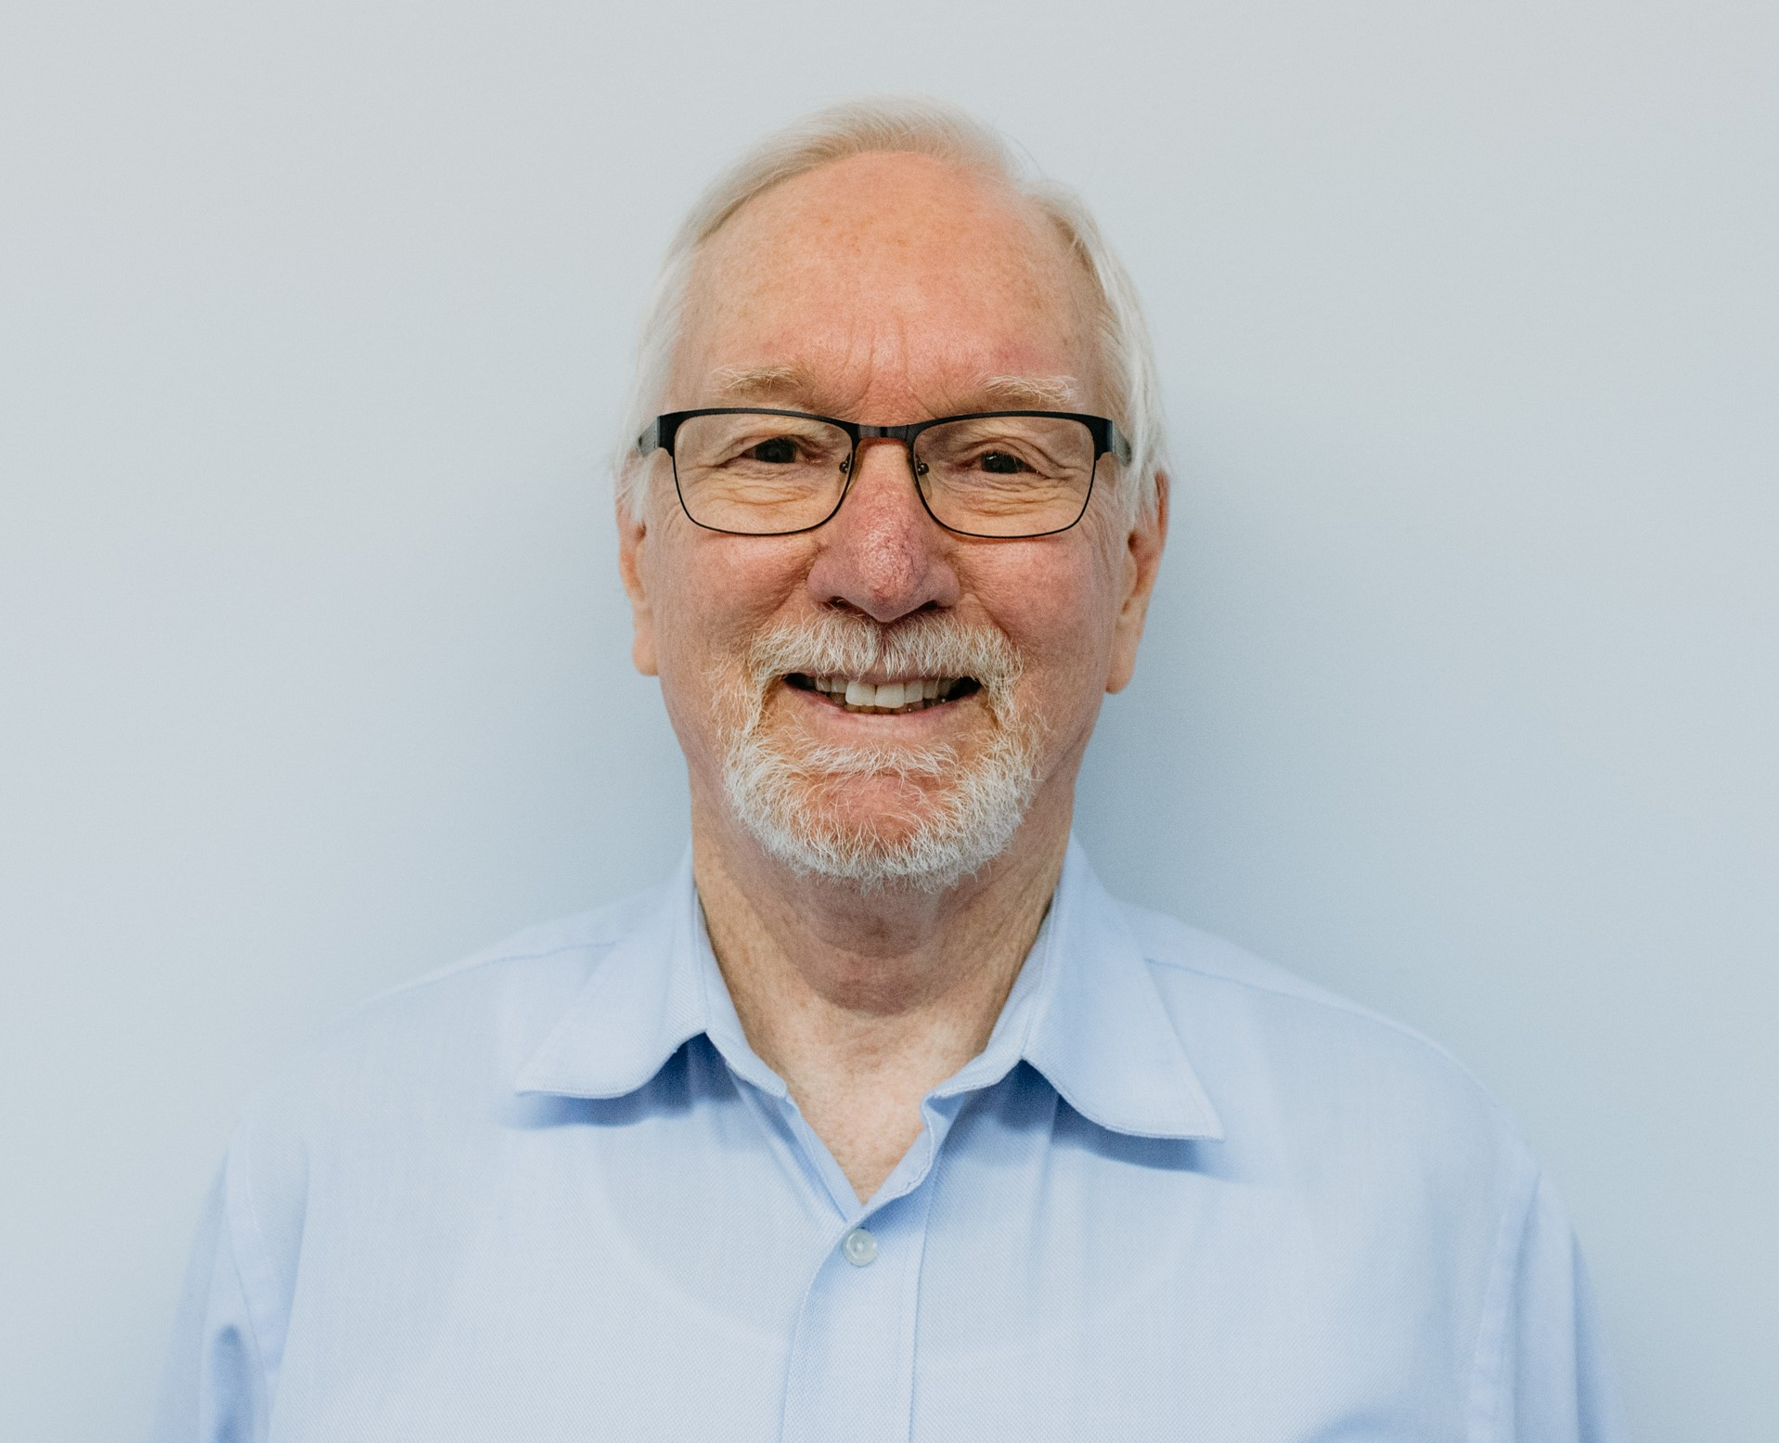
Secretary, SMC Representative
Daryl Climenhaga
Pastor, Steinbach Mennonite Church; Professor, Providence College

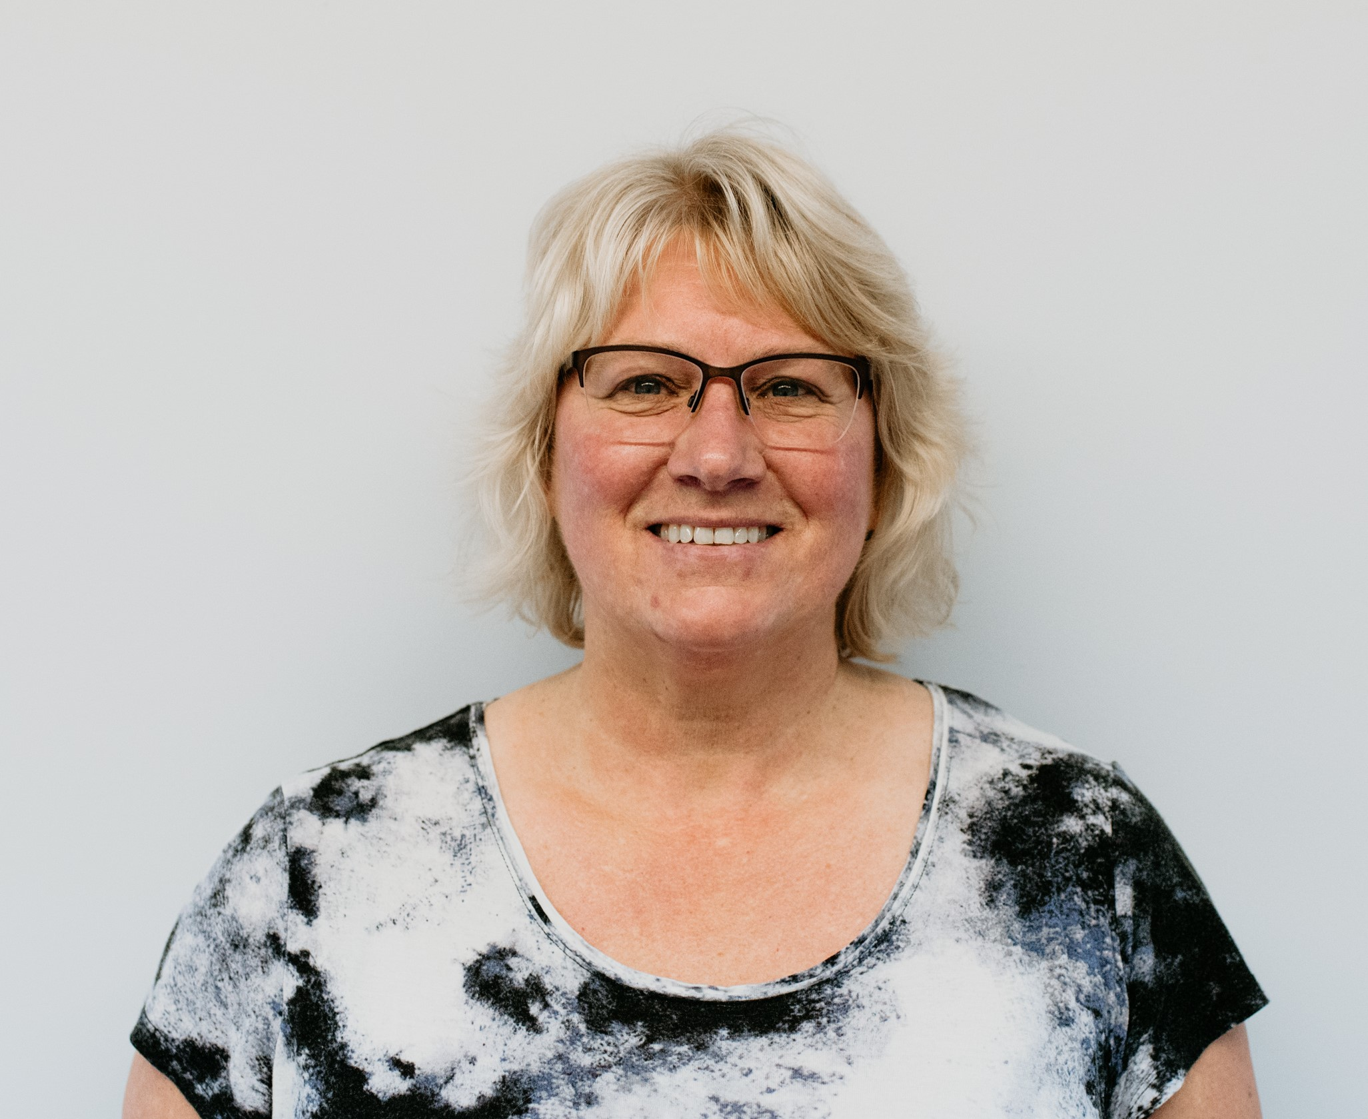
Housing Representative
Tammy Bekkering
Air Canada – Intermediate Finance Agent

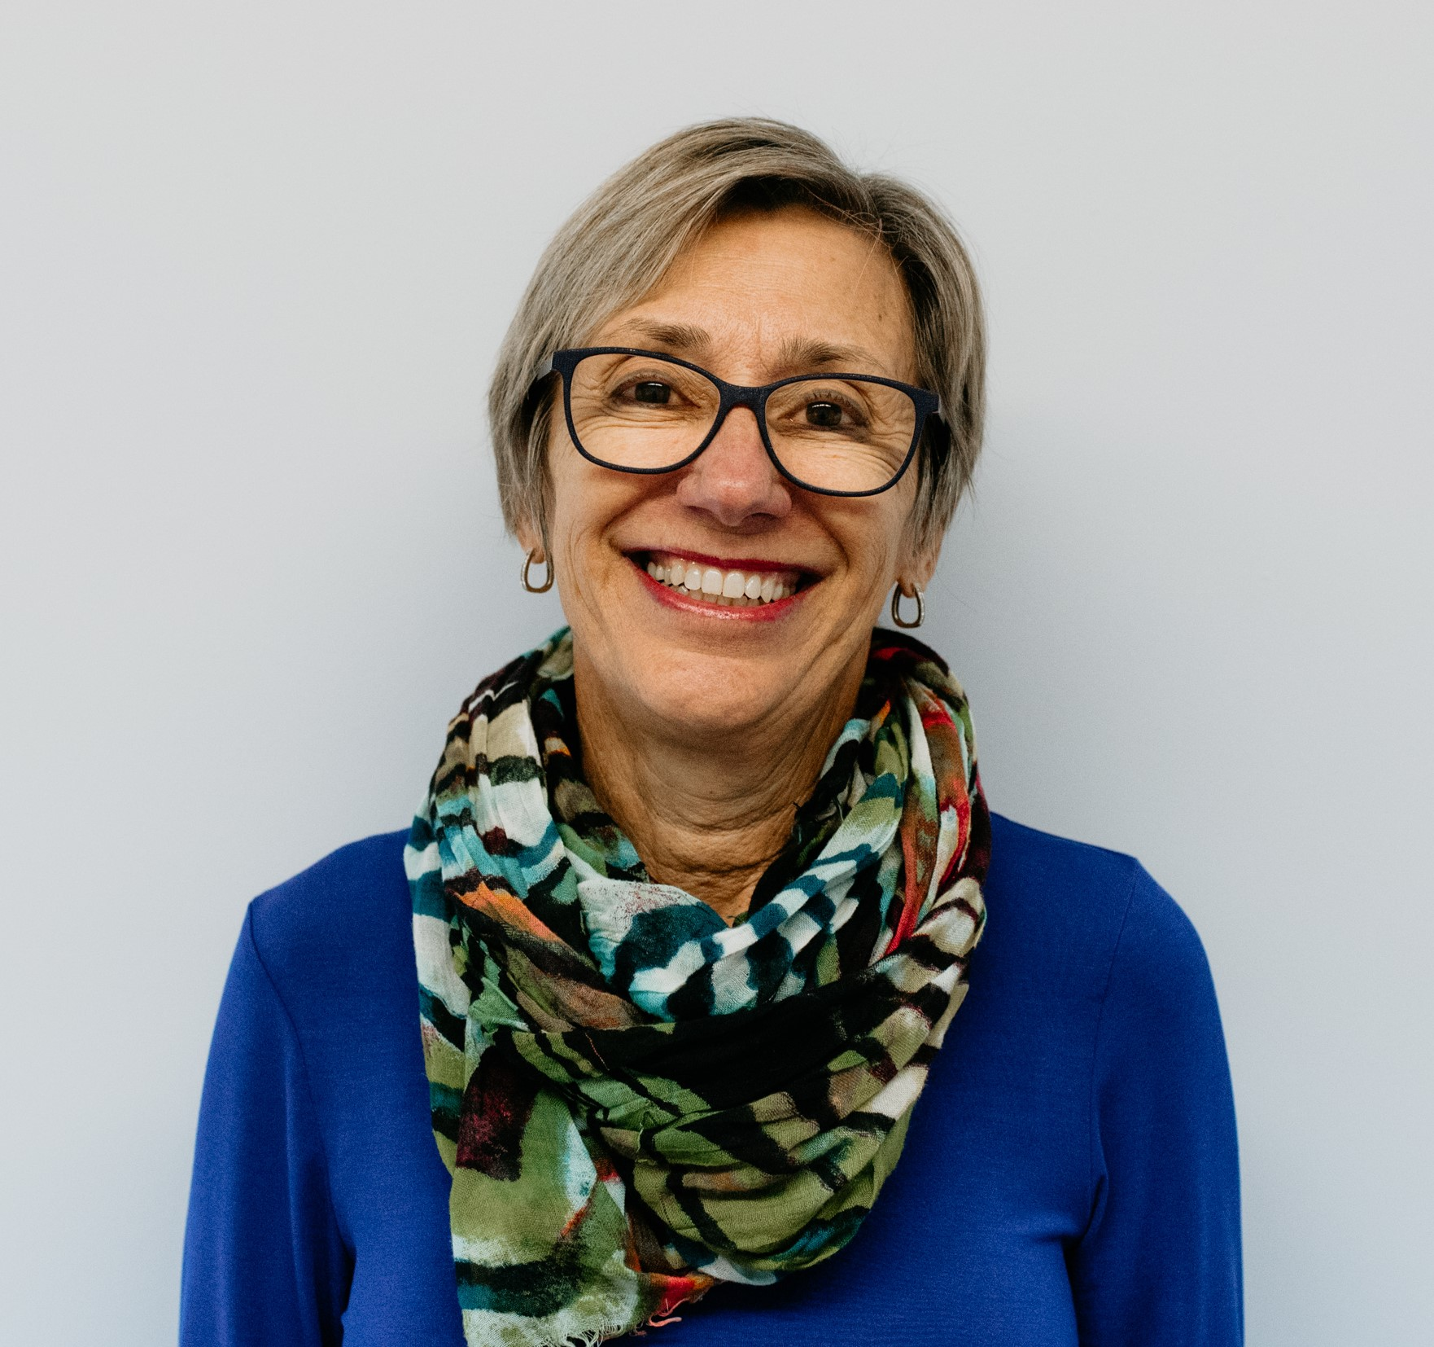
Member at Large
Ingrid Penner
Retired – Retail store owner/operator; teacher

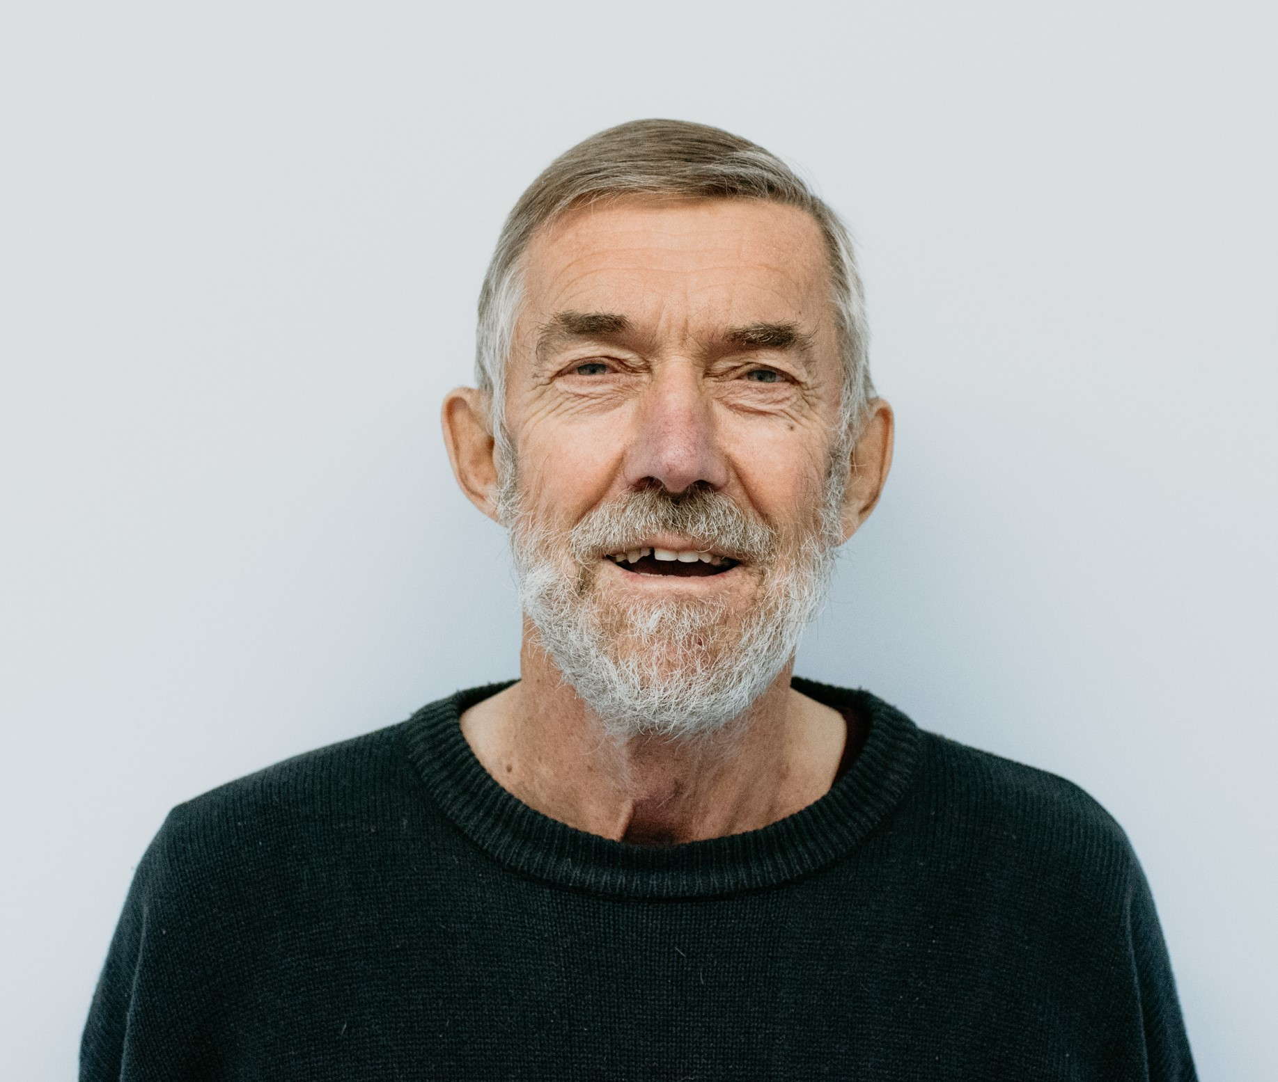
Member at Large
Eric Rempel
Retired - Agronomist

Member at Large
Brittney Penner
Doctor – Steinbach Family Medical Center

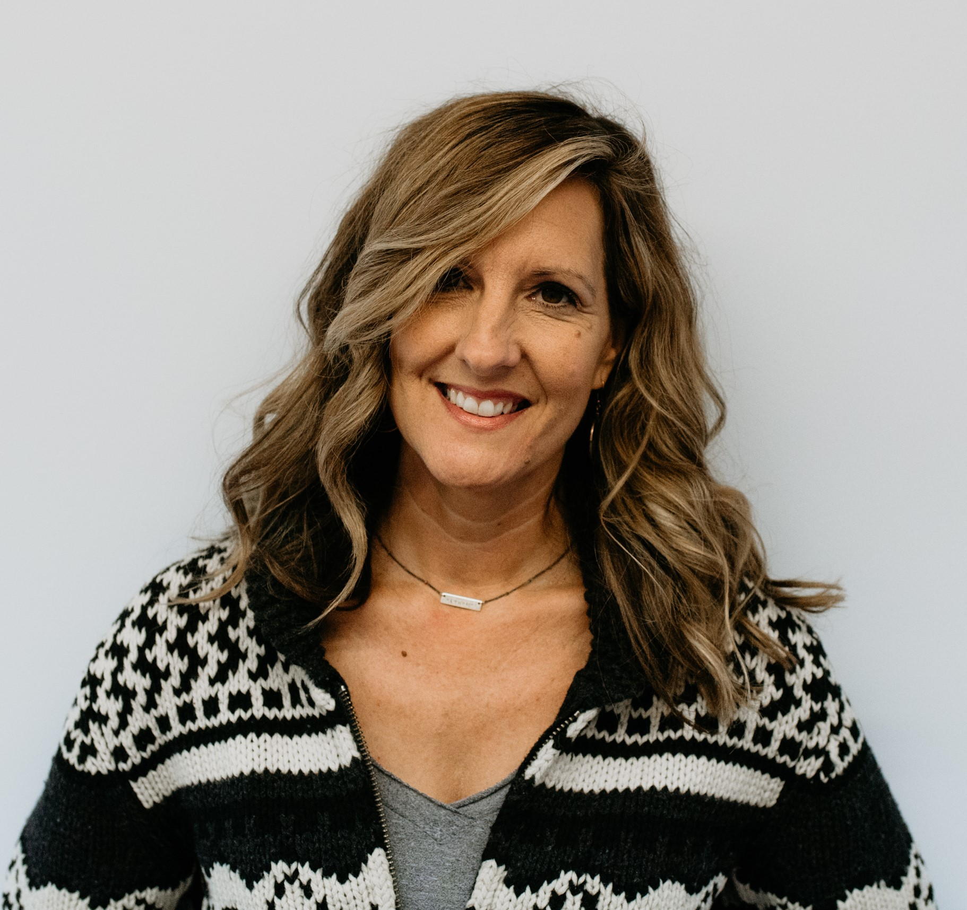
Staff
Drop in Center Director Office Administrator
Myra Gerbrandt Charlene Turner

tHANK YOU FOR YOUR SUPPORT

SCO would like to recognize and thank all of their donors for their support no matter how large or small the contribution. Donations vary from five dollars to thousands of dollars. Every penny donated helps our neighbors in need of extra assistance. Without the support from the members of our community we would not be able to do the important work we do.
Thank you to the following organizations for their support in the form of grants.

